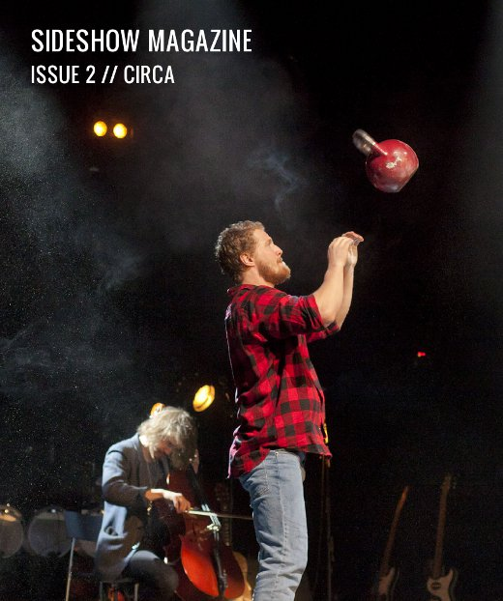
Table of Contents
Issue 2, Spring 2012
Professionally Interested, Personally Bored
The Rule of Art
Undermän
The Hanging Sphere
DeFracto: Circuits Fermés
Mathurin Bolze & Hedi Thabet: Ali
Stumble danceCircus: Box of Frogs
Compagnie L’Immédiat / Camille Boitel: L’Immédiat
Sugar Beast Circus: {Event(Dimension):}
CircusFest 2012
Colophon

Issue 2, Spring 2012

Reader! Welcome to Sideshow Magazine Issue 2, where, striking like summer lightning (FLASH!), we bring you extensive coverage of Auch’s Festival Circa a mere fourteen weeks after the event itself. (FLASH!)

Circa’s an interesting one — a ten-day festival of professional and student work that invites the participation of dozens of circus schools — and it’s covered here principally by a long yrstruly diary piece, a little frothy, which at times is probably going to read like the footnotes of the penetrating sociological essay I would have written about the behaviour of ‘key promoters’ if I had the jones (or, frankly, the penetrating sociological insights) to do so.

While at Circa I scored a couple of interviews that are represented in the following pages: one with Olle Stranderg, the director of Undermän, who speaks in a Nordically candid way about the triple-heartbreak that inspired the piece, about coming under the wing of Cirkus Cirkör, and about his own life as a performer; and the other with French director Aurélien Bory, famous more or less the circus world over for shows like Sans Objet, Les sept planches de la ruse and Plan B, and who was at Circa with his new piece Géométrie de caoutchouc. The end of the interview with Bory actually got clipped off because my dictaphone ran out of space and I don’t really trust myself to paraphrase the interesting things he was saying about the vertical/horizontal in theatre and workshop spaces, but can confidently communicate at least that one of his future ambitions is to open his own studio / creation space in Toulouse, and that he would like it to be more horizontal than vertical.

(I also interviewed Jay Gilligan at Circa, and that was interesting as well, but I got ominous carpal twinges transcribing the other two, so have let that one for now; it’s coming soon. (...FLASH?))

Leaving Circa behind, we have an article from US aerialist and choreographer and director Kevin O’Connor on his experiments in ensemble aerial; move thereafter into reviews, which cover productions at the London International Mime Festival alongside appraisals of Mathurin Bolze & Hedi Thabet’s Ali, DeFracto’s Circuits Fermés, and Stumble danceCircus’ Box of Frogs; and finish with a short preview of the Roundhouse’s upcoming CircusFest.

I hope you enjoy the exceptional cultural relevance of this up-to-the-minute coverage.

John Ellingsworth

Cover image: Cirkus Cirkör’s Undermän. Photo Mats Bäcker

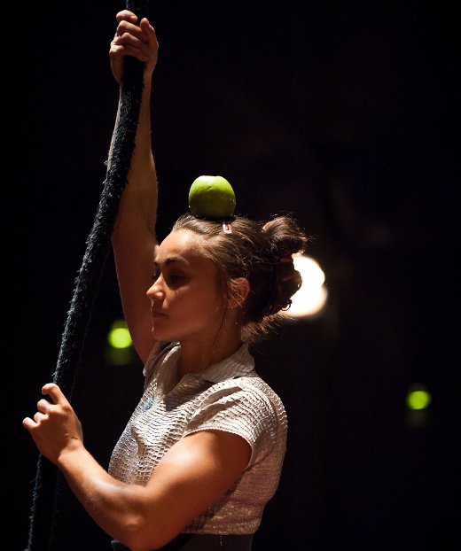

Professionally Interested, Personally Bored

Diary Entries from the Festival Circa Marketplace

One of the big names on the European circuit, Auch's Festival Circa is like no other; held in a small town in Southern France, it invites dozens of circus schools to present their work alongside a programme of professional productions, created, mostly, that year. For ten days students, circus enthusiasts and bookers alike descend on the town. John Ellingsworth is one of the incoming crowd...

Friday: Parallel World

2pm: Coming in by mini-van, crammed three to a row with promoters just landed at Toulouse, trying discretely to read the letter the woman in front is bumpily writing in French on her laptop, in a comfortable international silence and on a sunny mid-afternoon, Auch: framed in the windscreen, the hill rising steeply to the Cathedral, its wide, sprawling base flanked by a ribcage of flat stone supports that give it a stolid, sepulchral aspect. I’ve been here before, once, last year, and remember the route as we drive through the old town to the Maison du Festival, a municipal building requisitioned for ten days each year as Circa’s hub and information centre. It’s a hall, long and high, with a croft roof above and stone flooring below, the space divided by screens into a main area with a stage, bar, tables, etc; a canteen where students and other supported parties (e.g. freeloading journalists) can eat for free; and a crash-zone of comfortable sofas and lounge-ready beanbags ordinarily occupied by gangs of circus students. A wooden mezzanine level runs round three sides of the building — a wide balcony that houses the promoters desk as well as commercial ticketing, plus has small groups of tables and chairs welded in organic shapes from heavy metals. It’s actually the same configuration as last year, to an almost eerie degree, like the complex music box of the festival froze when I left and resumed when I crossed back over this threshold.

5pm: A couple of agents from the festival drive me to my quarters, the same place students from the FEDEC schools will be once they arrive, which is a huge boarding school a little way downriver of the old town. Up then to the third floor, pressing on timer lights and releasing magnetic locks, and to my room, a neat and self-contained little unit that still has the term-time occupant’s possessions packed away in a wardrobe (on which is bluetacked, over the head of the bed, for whatever reason, a clipped newspaper image of a woman knitting a cock & balls). I turn out the messenger bag I’ve been given containing the festival’s welcome information and sift through the bundle of maps and glossy programmes to find the photocopied, comb-bound, unredacted agenda, which alongside information on the 22 professional productions gives the lowdown on the dozens of student presentations (ranging from showcases of very young diabolists making their stage debut, to open stage afternoons for teenage acrobats, to CIRCLE, a festival-long series of twenty-minute presentations put on by the students of visiting FEDEC schools) and the extensive side-programme of public exhibitions, concerts, talks and professional meetings and receptions lasting every day from early morning to late night. In all there are scores of events spread over the ten days, but the first for me — and the only show of this abbreviated day — will be the closest to home: Welsh company NoFit State Circus’ Mundo Paralelo.

9pm: Work at Auch is early. With a couple exceptions, the shows in the programme have been created the year of the festival (though no one premieres at Auch — they always have a couple performances somewhere else first), which makes Circa both a magnet for the programmers of international festivals, who come to shop, and a place where you see work that’s still, mostly, in need of anything from a minor underhaul to a full-scale overhaul. With this in mind, NoFit State’s Mundo Paralelo, a collaboration with the Serbian director Mladen Materic of Theatre Tattoo, feels very much like a presentation of everything the company has developed to this point: it’s edging toward two hours long, and has an interval, and there’s an uncertainty or vagueness of purpose that comes from too many shifts of tone and a dramaturgy not adequately contained by the premise of parallel worlds. There are some things I like about it — mostly those parts, I suppose, where the circus wasn’t really used as circus, but was instead an element within a whole-stage visual composition. There are sections in the first half of the piece that have a sensitivity to the verticality of aerial that feels quite rare and unusual, and there’s an at times very strong sense that spaces are being created within the theatre — that high rooms and empty halls are forming and dissipating — yet all that’s suggesting this is a woman on a rope, a man on a ladder, and half a dozen squares of projected light. The second half of the piece, the dusk half, played out in crepuscular half-light, jump-cuts to something more like a presentation of the artists’ set-pieces and routines. The introduction of custom equipment (like a tightwire on a welded and internally rigged structure of cables, chains and metal poles — a cubist visual art interpretation of a rig) necessitates clunky set changes that are covered by some forced meta-theatrical gaming (two clowns playing with the controls that activate the theatre’s canned laughter and booing). But anyway: early, and I leave the theatre having resolved to come and see the piece again in three months at the London International Mime Festival, where much might have changed.

Saturday: Concept Circ

1pm: During an interview with Olle (pronouned: OU-ley) Strandberg, director of Poetry in Motion and a director and artistic project leader with Cirkus Cirkör, I make the mistake of sitting next to what looks like an uplighter but which through gradual, increasing insistence reveals itself in the course of the interview to be a mushroom-headed space heater emitting waves of heat that flow down, then smack up. Is Olle bothered? He seems Nordically stoic, not sweating, nor flushing, nor even glancing at the wretched heater as I take about twenty minutes and considerable muscular coordination to progress in an imperceptible glacial drift to the rightmost edge of my bench seat — the Polar region, comparatively. What OU-ley’s saying is interesting, though, and after we’ve run through the nominally formal questions the structured interview devolves into 40 minutes of watching YouTube videos while Olle tells me about his upcoming piece, Ballroom House, and his experiments combining street dance and juggling, giving artists randomised performance scores, shown also to the audience, that reveal the mechanics of how a sequence of movements is assembled.

4pm: I don’t get the wrong time for the Crida Cabaret. I get the right time and it just happens I’m in the wrong time zone. I gather afterward that it’s not so much a circus show but is, and perhaps not so surprisingly, a cabaret, held together and driven forward by the (allegedly) remarkable singing of Jur Domingo, a roughed-up chanteuse with the voice of a woman three times her age.

8pm: As the lights dim and a winter wind blows through the tent, two figures dressed all in white come slowly into vision, and the festival director sitting next to me leans over and proffers a small mint. ‘It’s ecstasy,’ he whispers. I decline, though several times during the course of the ensuing production I wonder what it might have been like had it been true and had I accepted. Rivages is one idea, executed by two performers: the man, Lionel About, is on the ground, manipulating two mid-length poles that can be fitted together and locked into one long pole; the woman, Marie-Anne Michel, never touches the ground, stepping on the ends of the staves as they are slid beneath each footfall, or climbing the height of the double-pole, held vertical and braced at the bottom by About. The movement is, with one — one — excepted moment, slow and deliberate, the choreography intricate within the bounds of its own self-imposed rule, like a flowing, crossing design contained in a circle. That winter wind motif, and the sound of footsteps crunching on snow, runs through the piece, but it’s very bare, and in a way tyrannically forces that bareness on the audience themselves. Just as there’s no relief for Michel, who can’t get down, nor for About, who can’t put down, we’re locked into a severe and single-minded interpretation of what is essentially the child’s game of a self-imposed rule: I won’t step on the cracks in the pavement; I’ll hold my breath until I reach the end of the road. But where a child freely abandons what they create, here there’s reverence and capitulation; for 50 minutes I feel trapped.

11pm: What we have for Kitsou Dubois’ Sous le Vertige is a square of dark water, black until disturbed, a shallow film that takes the heart of the stage. A heavy pole is hung over it, attached to rigging at a point one-quarter its length so that the three-quarter side dips toward, but does not touch, the water. There are two men in the space, notable in their difference, one a heavy-set older man, a dancer, in a grey suit and sporting a security guard crewcut; the other a young, inexplicably Oxbridge buck with leonine hair and rolled shirt sleeves. What follows is a series of thin variations on the basic action of the acrobat leaping onto the pole and the older dancer skirting the edge of the water, taking the other end of the pole, sometimes guiding the young man’s flight, sometimes disrupting it. It seems as though the idea is to set circus and dance, youth and age, and vertical and horizontal movement planes against one another, the dancer planting his feet very firmly and heavily as the acrobat dangles crazily. There’s perhaps some evidence here as well of choreographer Kitsou Dubois’ experiments with weightlessness (the acrobat’s limbs are queerly floaty, his body splayed over the pole as though he has fallen upwards into it), but an idea isn’t a show, and in spite of a few coldly stylish images, it leaves me with the same sense of substanceless conceptualism as Rivages.

And so with the day’s second interminable self-involved pole piece behind me, the imagined hearty laughter of the person responsible for its scheduling ringing in my ears, I return to my boarding school lodgings, where (as the circus schools still haven’t arrived) I have the shivery yet not unpleasant sensation of being the only human occupant of a building meant for several hundred.

Sunday: Catechism

4pm: In what will eventually become an Auch motif of persistent heat discomfort, the tent for âm, the 22nd end-of-year presentation of the Centre national des arts du cirque (CNAC), is hot as the roiling surface of the very sun. The audience, in substantial part students from other schools (arrived today), is like a crowd at a sports game, massed and tumultuous, starting up chants and slow claps as the process of fitting the seemingly unending stream of latecomers onto the bench seating draws tediously out, stewards/ushers approaching wedges of seating and making that compress! compress! gesture with their straightened arms, the audience dutifully shuffling on their arses toward a compacting centre.

These Circa performances are in fact the last for âm, which is directed by Stéphane Ricordel (described as ‘ancien des Arts Sauts’, which makes me imagine him, pleasantly enough, as a flying trapeze artist with a simple robe and flowing beard), and has been touring venues in France these last months as a professional production. It’s still a student show, though; everyone gets a turn. I’m disappointed by it — disappointed to see what are essentially acts from a school that’s turned out so many unusual and interesting artists, and to see another graduation piece where the director seemingly just fills in the gaps (here with variations on the theme of a giant wooden plane that’s tilted as a slope, suspended low as a swing, or high as a flying stage). Afterwards all I remember is the charm of a few of the artists as performers — particularly the puckish and adept cloudswing artist who, following a sham technical error, is forced to perform his routine to a piece of solemn choral music, and the acrobat who invented a suite of eccentric new movements while wearing full carbon-fibre skis — and then the spectacular if meaningless final image of rain, real rain, falling down in the centre of the ring, projected clouds flowing fast across the moving screen of the water.

5pm: Probably as a protest against the aggressive packing strategies necessitated by Easy Jet’s luggage restrictions my laptop refuses to power on — a fact doubly unfortunate given that getting ready for Auch I was directed once again by the fantasy that I would write all my reviews and articles while here, between the shows, and therefore pointedly didn’t bring anything to read or distract myself with. After a long walk along the bank of the River Gers (stopping in the scrubby park before one of the festival venues, the Hall du Mouzon, where boredom drives me to compose a poem about a passing toby dog) I’ve no choice but to return to the Maison du Festival and expose myself to the constant current of key promoters.

What happens when you bump into someone you know at Auch, particularly in those cases where that someone is a someone to whom you don’t have much to say, is you make use of the typical conversational icebreaker/crutch and run through this rigid catechism of questions: When did you arrive? When do you leave? Where are you staying? What have you seen? What have you liked? What are you going to see? Bumping into the same person as you did yesterday it’s perfectly permissible to rerun the exact same script, and in this way you can woodenly act your way through some rather staid interactions. (In among this there’s also, perhaps, a normalising effect: as we repeatedly illicit each other’s snap judgements on the work a sort of lumpen mass opinion begins to aggregate, and you can imagine the Programmers of Auch as a sort of secret society that vote shows in or out.) Today the catechism reveals that Le Repas has passed muster, a production which my schedule has ruled out but which involves getting bussed out of town for a cabaret dinner show, the circus artists performing around and over the tables — standard enough fare, except that it lasts all evening and the whole audience has to help cook the food and do the washing-up. There’s enthusiasm from many, though it’s understood as quintessentially French: ‘English audiences wouldn’t stand for it — £40 and then you have to wash-up for half an hour.’

Monday: Radio Circa

12pm: Whose terrible idea was this? I’m on the balcony mezzanine of the Maison du Festival, it’s just gone midday, I have a translator at my left, and I’m about to be interviewed on Radio Circa as one of four journalists invited to participate in a segment on critical writing and circus. The other three in the group are someone from HorsLesMurs’ Stradda magazine, a dance critic, and a reviewer for a French national newspaper. Public speaking is always problematic for me as an idea, but, as is the way with these things, the actual experience is altogether different, and the opaque screen of nervousness fairly quickly defogs under the hot air of all these opinions waiting to blast up. When the presenter asks a question about how the media should approach coverage of Festival Circa, I cast slitted eyes at the newspaper guy who’s hogging all the airtime, one of those critics who looks like he must consume or at least draw some calorific surplus from the shows he covers, and who’s admanant that it doesn’t matter what they cover or how they cover it — proof once again that mainstream media has the most resources and yet makes the least effort. I’d like to say something but I get passed over on the topic, and am asked instead the sensationally broad, ‘Where do you think contemporary circus is going?’. I manage about six blandly optimistic sentences and then that’s a wrap.

3pm: The book I’ve managed to semi-consensually borrow from a producer (Graham Greene’s Monsignor Quixote) has in short order revealed itself as the book a vicar or historian or grandfather might enjoy, a tedious and didactic novel about a town major and a Catholic Monsignor going on a low-incidence roadtrip. The dust jacket promises the ‘fleshpots of modern Spain’. I can’t affirm or deny this absolutely. At the midpoint, however, the fleshpot count is zero.

8pm: Karl Stets has many of the characteristics of a street performer — an easy (though here silent) rapport with the audience, a suite of crowd-friendly skills, the confidence to accelerate over any small bumps that might come from lapses in technique, and a seemingly bottomless accordion bag, black leather, from which the props of his show emerge. Cuerdo is a series of inventions using three cords of different lengths and thickness: one is rigged between two bamboo poles to become a slackrope; another winds itself as a cotton snake out from its hiding place inside a cane and over Stets’ hand, the visibility of the string that leads its movement no detriment to the sinuous believability of the puppet; the last, thin piano wire, is pulled tight around Stets’ face to turn him into a disfigured monster, hopping and lurching over the audience seating as he searches for the wig that will hide his bald head and cover two cauliflower ears. It’s very charming, and sometimes beautifully simple: when Stets walks the tightrope there are two bells tied at either end, one large, one small, and their irregular, delicate chiming — like the chiming of bellewethers, one far, one near — is the only sound. For the finale, Stets ties a simple knot in a piece of cord in ever more elaborate ways — one-handed, no-handed, lying on the floor — and it’s pure circus: a stubborn desire to do it the hardest way, and a recognition of the worth of what, to others, might appear worthless.

The show’s warm and very polished, one of the few at Circa that isn’t a new creation, and watching Cuerdo I decide that as a programmer it must be like looking at houses when you’re about to move: can you imagine what might fill the cold dimensions of a new build, or are you looking instead for a place that’s already been lived in and shaped to its owner?

Tuesday: Full Circle

3pm: There’s a tent at the base of Auch’s Cathedral, right in front of the great double doors, that’s given over almost entirely to the CIRCLE presentations. CIRCLE is, in a way, the heart of the festival — a week-long medley of twenty-minute presentations, three a day, from the various FEDEC circus schools. Circa has been built around them: the festival gives the students the opportunity to perform internationally (the non-French schools, anyway), to meet students from other schools and see their work (they can go to each other’s presentations for free), and to see work from a wide range of professional companies. The programme is even constructed with them in mind: the aim is to draw together a set of circus shows that represent different aspects of the contemporary circus spectrum, with an emphasis on new creations.

Scheduling conflicts mean I can only book in for one CIRCLE presentation, which turns out to be the UK’s own Circus Space. It’s pleasant enough. A twenty-minute confection that begins by establishing an office setting that it soon abandons, it is (and I suppose all the FEDEC shows must be like this) a mini-showcase where the students perform with their preferred disciplines but then whack in some acrobatics as well for the sake of the school’s good name. It seems to me fun and undemanding, though afterward I hear that it went down really well, and that some people were shocked by the skill level: Circus Space haven’t presented at CIRCLE in quite a few years, and the industry was stuck with this idea that they were technically second-rate. I hear also, later in the day, that one festival director has decided to programme the little piece already.

11.30pm: Through the miasma of French in Collectif Prêt à Porter’s Compte de faits (which features a cast of neurotic characters speaking extra fast) I can faintly discern that it’s set in the waiting room of a psychiatric clinic, and that the whole piece spirals in toward a past event or suppressed memory. The seats of the waiting room emerge from (and fold away into) a large bench packed with pneumatic machinery that can be lifted and spun, but it’s used sparingly, and the piece is fundamentally a play — the circus skills performed at the same time as the text: not literal, but the metaphor put right beside its explanation. Beyond that, I have no idea what’s going on. At the end the performers get something like four curtain calls as the young audience stamp and holler for them to return — giving the most enthusiastic response for any show I’ve seen here.

Wednesday: Professionally Interested, Personally Bored

2pm: Responding to the critical mass of programmers / presenters / circus people of power at Auch, HorsLesMurs each year organise two-days of project presentations at a bland conference-y building round back of the Maison du Festival. So in a low-ceilinged room that somehow reeks of Powerpoint, there are two banks of seating either side of a central aisle presenters must walk down (the Destiny Aisle). The chairs are generally fairly full, and at peak times crowds of extra attendees sit on tables or stand at the back, with numbers in the room ranging between perhaps 30 and 120. Presentations start at 10am and end at 2.30pm; a late morning slot is best, as by about 11am most of the promoters have rolled in and taken their seats (dividing into little delegations from different countries or institutions, so that if you were knowledgeable you could perhaps draw a map of the room to demonstrate the flow of relations in international circus; the English-speaking promoters cluster toward the back, hunched in around two whispering translators). Each presenting artist or company has a not very rigorously yet still actively enforced seven minutes, and it’s interesting to see the different approaches: some electing to speak for a minute, then giving the rest of their time to a video; some showing diagrams and concept sketches and getting lost in the complexities of a custom rig that looks like a medieval-era engine of war; others, usually in a slapstick style, throwing their chances behind a miniature in-character performance. Those who pick the last might have done so without a full awareness of the atmosphere that blankets these presentations, tense and heavy and migraineish, professionally interested but personally bored, and in the lobby of the building those about to present can be seen sat on the floor around spreads of notes, scratching out last minute alterations. As the morning goes on the energy slackens, and when the presentations break for lunch, few come back for the remaining 90 minutes, the regular festival programme making a greater claim on the promoters’ attention. By 2pm the artists are presenting mostly to each other.

3.30pm: Oh god, a clown show. Why am I even here? The performance arena is a small ring of wooden seats raised in what looks like a backstage area at the Hall du Mouzon, a sort of raked clown panopticon where there’s nowhere to hide. I lead the person I’m with to the absolute back row, fretting then about the ‘clown thoroughfare’ formed by the inviting channel of empty seating in front of us until adequate shielding is installed as a couple families come fill the space. I’m just thinking that I would like to squeeze in perhaps one more fat person to make the rows in front truly impassable, when our two clowns enter. Bibeu et Humphrey, long-ago graduates of Auch’s own Pop Circus, are trad clowns with makeup and red noses. She’s a solid, mischievous, slightly licentious bawd, speaking in a drunken grammelot; he’s a dopey and deliberate nonce who lifts the hem of his trousers meticulously whenever he goes to hop onto the inch-high stage.

They’re actually very good, delighting their young audience with some classic slapstick, and demonstrating they’re adept as well with clarinet and saw, accordion and trumpet. After leaving the audience relatively unmolested for most of the show, Humphrey clumsily trips and flings a glass of water out into the seating; Bibeu of course leaps into action, a growly, cackling laugh issuing from her throat as she bears down on anyone dampened with a ragged old towel. Once one wedge of the audience has been wetted and ruffled, Humphrey looks down at the glass of water in his hand, realises its power, and proceeds to toss water out on all sides. ‘GRAH HAHAHA,’ roars Bibeu, closing in on her captive audience.

5.30pm: Cie Nicole & Martin are down on the riverbank, in the small white tent, wood-ribbed, very beautiful, a little shamanistic, where last year I saw one of my favourite shows of the festival, Théâtre d’un jour’s L’Enfant qui... This time it’s La jeune fille sans mains, a Grimm fairytale which I’m slightly familiar with and which I’m hoping might in interesting ways recall the previous production. No such luck, no such poetry. It’s pantomime — in the broadly gesturing characters, in the melange of performance languages, in the purple tights clinging to the hero’s steely thighs, and in the simple, needy, insistent mobilisation of the audience. Snapping back from some interior dream I hear the woman saying: ‘Chanter avec moi!’ A reedy hum sweeps around the small tent like a lacklustre Mexican wave, settling into an uneasy rhythm. It is to singing what an Etch A Sketch is to landscape painting, each voice an iron filing jumping to form a blurry approximation of a vision conveyed by clumsy controls.

The kids in the front row are split about half and half (maybe on the basis of age) between those who are enchanted and those who are listlessly unimpressed (also in the front row, amid the Cherub faces, is a Swedish programmer staring catatonically forward as though the victim of a recent bereavement). At the end the company play their trump card, calling their own son on stage for the final moments of the production. As their dead-eyed little heir is brought on to play a music box, clothed tightly as a Regency prince, blonde that way all children are to a certain age, there’s an audible and also palpable change in the audience’s attitude: a softening, a thawing. Ahhh, perhaps it’s all right then...

8pm: In the Centre Cuzin, in what feels like a lecture hall, steeply raked seats flowing down to a narrow stage, there’s a perspex box. Everything else is dark; a small light is within, moving very slowly, illuminating tracery patterns on the plastic that look like frost whorls. In time, a hand rises, the lights slowly ramp up, and eventually, with a burst, there’s a man, naked from the waist up, his head obscured by a mass of plastic bags like the head of a dandelion clock. Seeing it now in full light, the box is the size of an arcade Claw machine, and its only prize is plastic bags, compacted down at the bottom. So then: Demain je ne sais plus rien, by Les Hommes Penchés. It is, as I’d been warned beforehand, ‘a man in a box for an hour’, and another piece that’s essentially been devised from a single idea, but certainly I like it better than Rivages or Sous le Vertige. The slow inscrutable silent character of the opening gives way to an uncomfortable style of desperate clowning, our man (Sylvain Décure) acting out a robbery that leaves him gunshot (he writes SOS in blood from his putative wound) or becoming entangled with a blow-up woman who he ends up deflating and sort of semi-eating in a clumsy fit of lust (several people leave at this point). He suffocates himself partway with a bag as well, and the whole piece is dominated by this sort of self-tragic, self-harming, narcissistic tone that doesn’t sit so well with me and that I think takes the punch out of the piece’s commentary on disposability, pharmaceuticals and the nature of consumer choice. I like the end though: from out the obscuring bags at his waistline Sylvain pulls, like a confused conjurer, a succession of objects: a pot plant, a TV, a small saucepan, a set of skis, a framed picture, a tape player, a cuddly toy, a toaster — the life debris keeps coming until it’s filled the box and he stands contorted in the middle. He pulls up, finally, a tape, puts it in the player, and as the lights go down the music plays him out...

10pm: Le GdRA’s Nour is a frustrating one to end on, but it’s my last Circa show. The set is white and open, sort of like a municipal theatre from the future, a trampoline hidden within a raised platform, personal items like a branded hoodie and a guitar held in stasis within glass cases. A back wall is filmed with projections, and at the start there’s text, and I can follow: it’s asking about identity. What is a person? The things they own, the place they’re from, the people they know? Can we understand a person only from their connections, as though the person is an outline that you can walk around to know the thing inside? But after that two of the four people on stage start talking across each other and I lose the thread of the show, never to truly regain it. One scene nonetheless stands out: a man falling on his back on a trampoline and being thrown running up a wall, again and again, and he’s talking into a microphone, between bounces, about his grandmother, and as he talks and runs a woman’s face, a video, is projected on the wall and the shot zooms in and in until the man is running up her cheek. I don’t know; it communicated. The rest looked interesting and thoughtful, and very dense; the audience weren’t exhilarated, but were absorbed, and left the theatre seeming exhausted and wrung-out. Maybe not such a bad one to end on after all.

Festival Circa takes place every year in Auch at the end of summer. The 2011 edition took place 21-30 October; John Ellingsworth visited 22-27 October and was supported by the festival.

In 2012 Festival Circa will take place 26 October - 4 November 2012 and will celebrate the opening of Le CIRC, a new creation, residency and performance centre dedicated to the circus arts.

www.festival-circa.auch.fr

For writing from Sideshow’s 2011 visit to Circa see:

www.sideshow-circusmagazine.com/circusfestival/festival-circa

Image: Cheptel Aleïkoum, Le Repas (photo Milan Szypura)

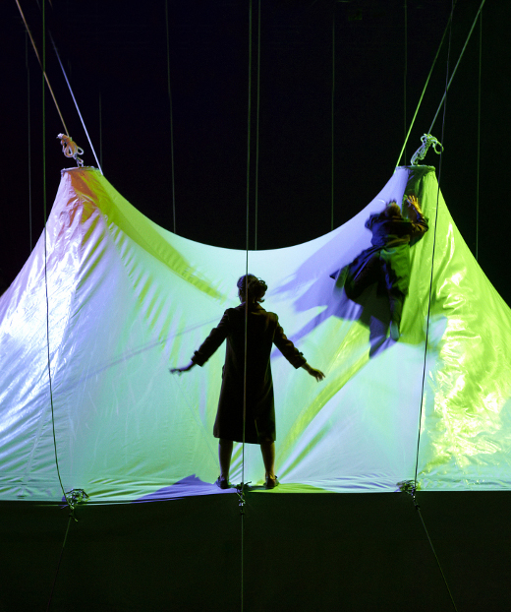

The Rule of Art

Amid the bustle of Festival Circa, Compagnie 111 director Aurélien Bory talks to John Ellingsworth about new work Geometrie de Caoutchouc, science fiction and the posthuman, mathematics and art, the attraction of circus, and bodies becoming space

Inside the vast dark tent is another tent, a one-third replica, lit from within by green, suffusing light. From four sides the audience watch it, the miniature, as figures press the material out — silhouettes the shape of a man, a woman, a bird, swimming up and drifting down. It takes them some time to emerge from their shelter; and when they do, they do so slowly. The motionless head and shoulders of a woman glide silently out from under the hem of the tent, as though on a conveyor, then retract. Others follow, climbing fully into open air. They are new humans, moving like young birds navigating a slope on foot, ungainly and unaware, as yet, of their inborn capacity. Their movement is rapid and halting, their bodies still in factory condition, flexible and unworn. They meet in ones and twos at the edges of the tent and then, with much trouble, climb the slick curves to stand atop it. With nowhere to go, they turn their attention to the material beneath their feet...

The director Aurélien Bory has been making work with circus artists for a little over a decade now — mostly under the aegis of the company he founded with acrobat Olivier Alenda in 2000, Compagnie 111 — and yet Géométrie de caoutchouc, his latest piece, is the first to be performed inside a circus tent. Technically, at times, it’s performed inside two tents, with the audience watching and surrounding, on rectangular banks of seating placed on four sides, a scaled-down replica of the venue they occupy. As a feat of matryoshkan set design, the staging gives a first indication of Géométrie’s intention to situate itself in a disruptive relationship with the traditional idea of the chapiteau as an icon of circus, but then Bory is not, and has never been, a traditional circus director.

Since the foundation of Compagnie 111 and debut piece IJK — an acoustic and spatial extrapolation of the fundamental aspects of juggling — Aurélien Bory has made a name for himself with a series of large-scale works that explore the properties of materials and spaces to create a kind of living scenography or architectural puppetry: in Les sept planches de la ruse fourteeen Chinese acrobats animated a moveable set of geometric shapes inspired by the Tangram; in Sans Objet the stage was dominated by a towering industrial robot arm (formerly part of a factory-line that assembled cars); and in Taoub, his collaboration with the Moroccan collective Groupe acrobatique de Tanger, the changing set formed and reformed from a single sheet of fabric. In Géométrie de caoutchouc, which premiered at Le Grand T in Nantes before heading to Auch and Festival Circa, it is the tent itself that comes to life: once the performers have emerged from inside the replica, the ropes tying it down are disengaged and the canvas flies up like a genie or rushing god, billowing and settling high above. Its face, squarish and pale, not unlike the face of a colossal heavenly owl, is animated by two metal discs with a transfixing gaze.

Thinking of this moment of startling animation, I first ask Bory, when I meet him at Circa, what the creative impetus was behind Géométrie de caoutchouc. Was he working with the tent as a rich, historic symbol, or simply with the physical properties of its material — the ways it moves, reacts, rests? ‘It was part of my interest to take an architectural space that is very well-known,’ answers Bory, ‘and to make it so that very soon there is not this idea of the tent as a symbol, but just the idea of the space itself and the relationship between the actors and the space. I’m very much more accustomed to theatre spaces, but in all my shows I try to start with questions about the space. I take the stage as very important and think about that, and all my work is around space: theatre seen as the art of space. Sometimes I am asked, Where is the humanity in your pieces? And I say I try to put humanity in the space — the architectures in Les sept planches de la ruse are alive; the space in Géométrie is a kind of... something. At the beginning it is more or less static, but it becomes more and more alive; it moves. And the actors themselves, I like it when sometimes the actors are less alive — they are alive but, for example when they slide very slowly down the fabric of the tent, they are less alive; they are like objects becoming part of space. They are not human beings anymore, they are just little pieces of space. So I try to make space more human and to make humans more like space.’

The performers in Géométrie de caoutchouc are not always inert, but they do act passively — or allow the space to lead them. Once the new humans are out in the open we see them draw together and form a sort of proto-society, becoming like a broken memory of a working group, cooperating to perform actions which its members don’t understand. When the tent is released the performers, eight of them, each take a rope and race and fall across the stage to pull the canvas down into a sail, looking tiny and confused as they scramble amid a chaos of ropes; later, with the tent held back at ground level, they run jerkily around its edge, appearing and disappearing behind billowing canvas that receives the image of mad shadows skitting along. Always there is something disconnected in their movement that suggests they are navigating from one impulse to the next, no thoughts beyond the present action.

In Géométrie perhaps it has found very pure expression, but all of Bory’s work begins from the idea of considering the space as itself an actor: ‘I try to work with materials that do something to the actors and to which the actors can do something. It is the actors themselves that push the elements together to build these architectures, but at the same time they are passive, doing what the space tells them to do.’ Is it the ability of the circus performer to flexibly occupy and respond to space that attracts Bory to the artform? ‘Most of my shows are with circus artists, and their background is in circus, but in my work it is with more of a theatrical conception. In terms of action or in terms of relationship to the audience there’s something theatrical and not something circus. What I tried with Géométrie was to take this space, this circus space, and try to push it toward the theatre.’

Working on the borders of theatre, circus and design, perhaps the unusual quality of Bory’s work lies in a desire to extrapolate the qualities of a circus artist and gift them to an object or a space — an idea that found its clearest expression in Les sept planches de la ruse, where a triangular block, balanced precariously on its point, had some of the same tension and simple drama as an artist holding a handstand. Bory nods at this: ‘It is the same drama. It is a mix between puppetry and circus. But if you think of circus artists, they are dealing with objects most of the time — even the acrobats because they have the trapeze. With the trapeze or the unicycle or the juggling ball what they are doing actually is just testing the possibilities of this object, and I think that space, in all of my shows, is a little bit like that. The actors have to find or experience a possibility of this space or object, and this is why I like to work with circus artists: a dancer is dealing more with the body itself or the body in relationship to the floor — the floor is very important in dance. For the circus artists, yes the body is a tool, but it is not really enough — what the circus artist is doing is experiencing the possibilities of the body in relationship to some simple or complex object, or with some simple or complex space. This is exactly why I’m making my shows with circus artists. Of course they are also puppeteers. They are trying to make alive something that isn’t alive; something that is just a rock or piece of wood. I feel really at the intersection of all these forms — circus, puppetry, theatre, dance.’

Working with circus artists and circus skills also comes naturally to Bory as a former performer. He hasn’t been onstage for a long time, but he trained as a juggler and performed in Compagnie 111’s IJK. ‘I feel close to circus artists,’ he says, ‘and in terms of process I’m exactly the same as when I used to be a juggler. I could say in fact that I am a juggler now, even though I’m not juggling. I think I haven’t changed — I’m interested in the same problems. You can think of Les sept planches de la ruse as a big juggling, balancing problem, and what I liked with that show, and what I didn’t expect, was the danger — we felt the danger of circus. With circus most of the time now we don’t feel this danger... I don’t know if it is a good or a bad feeling. I don’t know if I like it or not, but I know there is some danger in Les sept planches and I like the idea of danger — not real danger of course, but the idea that life is dangerous. Very much as you say in French mortelle.’

Mortality — and, more broadly, the nature of humanity — is something that seems to lie at the heart of Bory’s recent output. Sans Objet, particularly, was a striking science fiction fable that explored the idea of machine obsolescence as a metaphor to approach the question of what qualities make a human being a human being, interrogating the assumption that humanness can be identified by a checklist of physical characteristics. In Géométrie de caoutchouc, after the new humans have released the tent and explored the stage — explored the limits of their containment — they try to go back: bring the tent to earth and crawl back under the canvas, which, its energies dissipated, lies flat across the stage. They’re where they began, but clearly it’s not the same, and can’t ever be.

Whether Géométrie’s simple movement from order to chaos to void is read as a metaphor for the rise and decline of religious belief, an environmentalist parable, or a tiny enactment of the eventual heat death of our universe, the show is grappling with some of the big themes of science fiction. Is Bory conscious of this? ‘To me it’s funny because science fiction is not very easy with theatre,’ he says. ‘I think cinema or literature are fantastic for science fiction, but theatre... most often you see something very cheap; you can’t do big effects so you have to play with the idea. With Sans Objet the science fiction theme was very obvious because with these robots I wanted to talk about posthumanity and where it is that we’re going — but also about our past because technology is not from today. It is an old idea, technology, and I try to say in Sans Objet that technology has been part of humanity from the beginning, and humans and technology developed in parallel. Technology is now the dialogue of the everyday, and it will be more and more. Nothing can stop that. I didn’t want to say if it was good or it was bad — not at all — but to say that it is part of our world and it modifies our relationship to the world, how we live...’

In Géométrie, though, the technology isn’t at the centre of the discussion because there is no technology. ‘Instead there is this idea,’ says Bory. ‘What is the experience of living? What is the experience of living on Earth and in this universe? So there’s a universe at the beginning of the show, with the shadow puppetry, and at the end also when there’s this space. At these moments I see something physical connected to the universe; another person could see something else, but for me, in my imagination, it is something connected with physics, the universe, elements. What is the life and what is around the life? What is before the life and what is after the life? So this show is kind of first life and then the afterlife — a flat nothing which is like planets with no life, a desert. It is less of a science fiction show, but it is connected with another world because it is another world. It is a dream of another world which finally finished the same.’

But even though he has his own narrative interpretation, Bory is insistent that the work should be left open for the audience: ‘The show is experienced by an individual as a unique set of ideas, stories, references, and this is the real story — not the one I used to create the show. I used to say, “Yes, this is my understanding of the show”, but now I know that my understanding of the show is not more important than any other understanding. I want the imagination of each person to be very active during the performance, and this for me is very important: that a dialogue starts between the viewer and what’s happening on stage. This relationship is really for me the definition of art. Art is a relation; it is not the object itself. Only if there is a dialogue when this object is made, only if it makes me think something more, makes some connection, makes me think of this or that, makes me feel this or that. Because then we can say this is art because it is happening in our inside space. This is why I really care that there is space for slowness in my shows. I want to create some space for people to have time to choose their reason. I don’t want to rush things — which is also struggling a little bit against the circus concept, which is to rush things.’

One of the most unusual and obvious manifestations of Géométrie de caoutchouc’s slowness is that there are no unique actions — every movement is repeated. When the new humans slide down the fabric of the tent they do so over and over; when the tent is released and they pull on its ropes to draw it this way and that, every configuration is repeated four times, for the four sides. ‘It is at the same time something good and something bad,’ says Bory of this repetition, ‘because what I did is very logical. I followed a very mathematical structure. There is less life in that idea — it is an organised way of doing things. One time for each side; four sides, four times. So there is some mathematics here, but that’s not really why I wanted it: the repetition is more to embrace the whole thing and all the possibilities. Meaning life is a finite space; when you have experienced all that you can experience there is nothing else. And I really wanted to give that idea — that it is all that we can do; possibilities are not infinite. It’s a pity, it’s sad, but it’s true. And the older we get the fewer and fewer possibilities there are; so this is more at the end of the show. At the beginning of the show you have the sense anything could happen, that everything could happen. When they’re at the top it is chaos, it is possibility, it is people, many people, everything. At the end there are very few possibilities, so it is sad. They don’t have a lot of possibilities or choice anymore, so they just do what the space asks them to do.’

Matching the at times austere dramaturgy, the piece has an unusual score — sparse, solo piano composed by Alain Kremski. ‘It was a very odd proposition to bring this composer to a circus tent,’ says Bory, ‘because of course a piano solo is not music for a tent. But I had this intuition to have a solo piano, and I was pleased to find that this intuition really worked in the space. His music tells us something about the space, even the acoustic of the tent; we really use the acoustic of the tent. We don’t know where this music comes from — it comes from everywhere. You cannot say where the speakers are. I struggle with that all the time. I don’t know where to put speakers in order not to hear them, to not hear the origin of the sound, but in this tent you don’t know the origin of the sound. And this piano works very much in this composition about space... We also had some noise from the stage — all the noise that we hear in this performance is live; it is the sound of the tent, of the set. I used the acoustics of the tent because inside the little tent what you hear is incredible; we just put four microphones inside to produce all these fantastic sounds. So it was a good combination of beautiful piano — very simple, very economic, very slow, but very beautiful — and these sounds that are also very beautiful but in a different way, closer to the idea of chaos or accident.’

In light of these decisions — the repetitive structure, the slowness, the unusual music, the big, diffuse ideas — I’m curious whether Bory feels that Géométrie was a difficult or a risky show, and ask him as well whether it represents a change in his way of working. ‘Géométrie is my tenth show,’ he says, ‘so I have more confidence now to try some very difficult things. My problem in my previous shows was to seduce: I had to seduce the audience in my first shows because I was very frightened to disappoint people. And of course with that mindset, consciously or not, you put some limit on the work. Always in my work it was this combination with humour; I like very much humour, and in my previous shows there was a lot of humour to balance a little bit the reports that I had from the audience in slower moments or when it came to some more visual element. And I really like this mix, but... I did that.’

‘For Géométrie I wanted more. I had to say, OK, do something. Do the thing that you really feel, not considering if this person or that person will be disappointed or not. To be more courageous. And what happened to help me was I had some partners, co-producers, and the Fondation BNP Paribas helped me a lot, so there were all these people putting money in and giving me time to work hard on this project. And I said, OK, now the only rule I have to listen to is the rule of art. To try to make something the most sincere, and the most deep, the deepest I can. To try to make something important. And not to say that it is good — because I don’t want to say that. But to say I have to be the servant of art — more and more to be this servant. It gave me more courage to face criticism or people’s disappointment. And this kind of art you can have in some places of course, but putting it under a tent in front of 700-800 people... it was very dangerous, but I really wanted to experience that.’

‘Each night in Circa there are people walking out before the end. I have no problem with that. I know that it will happen. But I like this situation, and for me it makes some sense that some people are going out after 20 minutes and other people really take this show on their soul forever. It is a big contrast — art is made for that I think. I like humour, but there is no humour in that show. It is not what the work needed.’

Aurélien Bory is the artistic director of Compagnie 111, which he founded in 2000 with the Olivier Alenda and which has produced, to date, eight productions (including Plan B, Plus ou moins l’infini, Les sept planches de la ruse, and Sans Objet) and two collaborations, Érection and Arrêts de jeu, both with Pierre Rigal.

Géométrie de caoutchouc premiered at Le Grand T, in Nantes, 11 October 2011, and was at Festival Circa 24-28 October 2011. The piece is currently touring, with its next scheduled performances in France at the Cirque Théâtre Elbeuf 13-15 April 2011.

In 2013 Compagnie 111 will present a new collaboration with the Groupe Acrobatique de Tanger in Marseille as part of the city’s year as a European Capital of Culture.

www.cie111.com

John Ellingsworth interviewed Aurélien Bory at Festival Circa 25 and 27 October 2011 next to the Radio Circa studio/booth at the Maison du Festival (part I) and sitting in the unseasonably warm sun outside key-promoter hive Café Sol (part II).

For a review of Compagnie 111’s Sans Objet, see: www.sideshow-circusmagazine.com/magazine/reviews/compagnie-111-sans-objet

Image: Géométrie de caoutchouc. Photo by Aglaé Bory.
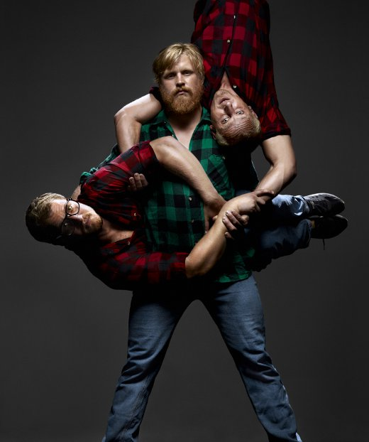

Undermän

John Ellingsworth talks to Olle Strandberg, director of the runaway success Undermän, about autobiography, circus texts, the affinities of circus and street dance, working for Cirkus Cirkör, and having to start over after you've lost everything.

I saw Poetry in Motion’s Undermän in February 2011 at Subcase, a two-day programme of new Scandinavian work shown at Stockholm’s Hangaren venue and attended by an extremely tough in-crowd of producers and programmers. It was only the second public showing for the piece — a raw, new work thrown together by a young company — but it was still by a long way the best performance there, an autobiographical heart-to-heart performed by three hand-to-hand bases (Peter Åberg, Mattias Andersson and Matias Salmenaho) who had lost their romantic and professional partners. In the following months, Undermän came under the wing of Swedish giants Cirkus Cirkör and embarked on an international tour that took the show to Belgium, the Netherlands, and, in October, to France for Festival Circa, where I caught up with the show’s director, Olle Strandberg.

The style of the show is very stripped down in terms of its set and aesthetic, and it’s based on autobiographical or real life stories. Is that something that’s sort of a Swedish or Scandinavian aesthetic, influenced by other companies, or is it your own style?

It comes a lot from our aesthetics and my aesthetics, and it’s a mission of the whole piece to show some reality or to reveal the true people, the individuals, on stage — to not do too much theatrical acting and to just let it be what it is. You get to know Mattias, Peter and Matias as the people they are, and Andreas as the musician; they’re not hiding anything, and we didn’t need to bring more props in because the ones we have — the kettlebells, the instruments — say so much in themselves. I’m a bit fed up with performers who, if they have ten seconds of nothing, always have to fill it with a lot of impressions or with a trick; it’s so nice with this performance that you can actually look at ten seconds where nothing really happens and the ambience is just building up. A lot of people actually get uncomfortable because at the beginning it’s quite slow, and at the beginning people are saying to themselves, ‘Wasn’t this supposed to be a good show?’ and ‘Aren’t they going to do any circus stuff?’. It’s a really nice moment where people come in with a lot of expectations and they have to just sit there for a while and listen to a corny song. I think it’s interesting to just let the time pass and I think it’s a bit like when you wait for someone, or when you’re away from someone, and you actually have a lot of time where you just reflect on the past somehow.

The performers in the show speak — and speak directly to the audience. How did you arrive at the decision to use text and do you feel that it creates or carries an effect that you couldn’t have gotten any other way?

Of course it was a hard decision to make. Personally I don’t need to have text in a performance when I watch it. I think you can take in a lot without text. With Undermän I think it would be possible without text, but then there’s something about having these quite manly men — manly somehow even though they’re kind of young — and hearing them really speak from the heart.

Then in Matias’ last speech we’re also playing a bit with that sort of pretentious dance scene where there’s this microphone at the front of the stage and people walking up to it to talk about themselves. It’s like sometimes when a company want to get deep really quick they use text. Matias’ speech is fun: it could have been really pretentious — we’re doing the same thing as all those contemporary dance performances — but the intention is something else, serious and not serious. It’s still from the heart, but he’s playing with this form of acting somehow.

I think the speaking is also a quick way to relate to the performers, and that it makes it easier to then communicate through music and circus — because there’s a lot of music all through the show that communicates as well. The guys wrote the texts themselves when they were missing their partners in real life, and we’ve just put that on stage; in a way it wasn’t meant for stage, so it’s a big statement for them.

The personal stories in the show connect with these overarching ideas of male identity and friendship and the nature of life on the road. Did those sorts of themes emerge organically or were they the original inspiration and impetus for the piece?

It was very important from the beginning that the show would take up the issue of male... not only friendship, but love and friendship and what it’s like to be a man somehow — and to just try to be honest about it. I was in a dance show myself a couple of years ago that was called Polare; it’s performed by three generations of men and it kind of plays around with the topic, and I do feel like it’s very important for circus to bring up those kinds of issue — especially because in circus, and in hand-to-hand acrobatics, your partner in your career is often your partner in your love life; this brings some extra importance to the show I think.

In Finland we did the very, very first show and we had these Finnish lumberjack guys crying afterwards because it connected to them as 50 year-old lumberjacks; one guy came to me after and he was crying and saying, ‘This is something that... that really wants to say something’. It’s amazing, to have a circus show that connects to men who are like 50+ lumberjacks. How do you get beneath the surface of that person, the shell of that person, and touch him?

Have you had any other gigs performing to audiences outside the circuit of circus and theatre festivals?

It would be really nice to do it, but I think it’s very hard to reach out to these communities to make them buy the show. Often when you do a tour in Sweden or Scandinavia it’s toured to 15, 16, 17 year-olds but never toured to like construction workers. It would be really cool to do that, and I think the guys would love to do it, but it’s hard to create a tour like that.

One thing that’s changed with Undermän since I saw it at Subcase is that the show is now produced by Cirkus Cirkör, and is being presented as a Cirkör show rather than one by your own company, Poetry in Motion — and the aesthetic of Undermän is of course very different to Cirkör shows like Wear it like a crown or Inside Out. Do you see that as a problem?

It’s a problem, but I also see it as an interesting problem. For us it was very important that it happened. Undermän is 100% not funded — except by my bank account, which wasn’t really fit for purpose until I took the loans. Also we were aiming quite high with the show — we wanted to do a fun tour, we wanted to do a show we could stand up for, and the touring is actually also a concept in itself: it’s Undermän and the continuation of their travelling and, hopefully, their success. We could have managed to do a tour ourselves — a lot of schools in Sweden were really interested in the show and I pushed it to them a lot, but I knew that if we were financing it ourselves we’d have to do 200 gigs at schools to get the money to do the show the way we wanted, to put in the musician with the salary that we wanted. We had so little time to sell the show for the fall; without Cirkör we would only have made like six or seven shows this fall, and we couldn’t really wait for things to start happening.

Also, I’ve known Tilde [Björfors] since I was a kid basically. As a concept selling the show was really far, but on a personal level it wasn’t so far, because I knew everyone in the company, and because Mattias, Peter and Matias have all worked in Cirkör on and off.

I’ll also be working in Cirkör as a director for awhile, and as an artistic director and artistic project manager, so Tilde will be doing some shows and I’ll be doing others. My aesthetic is very different to Tilde’s, with different thoughts behind it, but when Tilde and I talk we agree on a lot — our idea of what a show should be is very different, yet the reason why a show should be is quite similar somehow.

If you talk to the more political, concerned producers around Europe then our selling the show is a big problem. ‘I will not let you play in my festival now because this is not a Cirkör show, it’s a Poetry in Motion show. You’re fooling the audience.’ But like we’re the ones doing the show, it’s a great show, we had great fun when we created it and we can have even more fun doing it. We didn’t do it to get money and fame, but we do have monthly salaries now. Cirkör invested a lot of money into the show just to keep it rolling; they haven’t broken even. You get a lot of angry and frustrated French or European programmers that hate the fact that I’m with Cirkör and I have to just explain that it’s like this. We love the producers and staff of Cirkör. They’re great people to travel with and work with and talk to. I learn a lot, working with them and seeing from the inside how Cirkör works.

You mentioned you’ve known Cirkör a long time. Perhaps you could say a little about your own background and how you came into directing...

I started out doing juggling when I was ten years old — not connected to circus, just juggling for itself. And about ten years later I realised juggling was part of this bigger thing; circus wasn’t established in Sweden then, around ’95 or ’96, but it was actually when Cirkör started out that I got connected with the scene and found people I could practice with. After training at a gymnasium outside Stockholm, I went to the École nationale de cirque in Montreal, but found when I got there that Jay Gilligan had started as a teacher in Stockholm and as a juggler I preferred to go there. I was really into acrobatics as well, doing a lot of teeterboard and floor, and after school I started touring with Cirkör: I was in their Mermaid production for three years and then I broke my neck doing teeterboard. That was 2005; I was paralysed from the throat down. I was in the hospital a couple of months and we didn’t think — because it was fourth and fifth vertebra — we didn’t think it would become any better. And then I got better, quite quick, and I started a new production like six months later with a teeterboard group. I didn’t do so many technical things; I was 20 kilos lighter, and I did my best to do everything but I kind of sucked in that show I think.

You weren’t scared to come back to it?

It was my first mission when I got injured: I have to go back full out. I did it, but it was a bit early I think because I had the technique — I was technically good — but physically I didn’t have the muscles anymore. I lost everything. But I get so restless when I’m not physical, so I started out doing street dance. At first it was as something that wasn’t related to anything else where I could do it for hours a day without thinking creatively. I just wanted to move for hours a day. I did it for years, at the same time as I was teaching acrobatics at a school in Stockholm, and then I realised that the street dance culture actually has a lot that’s interesting — like I really liked the freestyle culture — and I got into it for real instead of just doing it for fun, and started producing street dance festivals and different battles and stuff. Me and a guy called Erik Linghede started a company called Poetry in Motion, combining some juggling and circus elements in the productions as well. Erik’s a producer, but a street dancer and popper as well.

So kind of from there I started dancing more and then got into contemporary dance, and I toured with a company for three or four years. Circus is what feels most important to me, but I got some clues from some other artforms that led me to what I wanted to do, which was to develop contemporary circus and let it be the thing I was longing for.

I still feel like I could definitely do shows myself on stage, but I’m years away... I want to feel really good about it. I want to be able to do certain things physically; otherwise it would just be text and movement in my show and no circus, and it would be nice to actually perform circus and acrobatics in my show. I want to pay respect to the circus.

So you see the subject of Undermän was kind of natural: you have everything and then you lose everything, and you have to start over. It’s like a theme in my life and it could have been the Happy Ex-Acrobat Show or something where you have acrobats that are all paralysed, but they’re like awesome performers and how could we create something from that? But in this case I’m good friends with Matias and the guys, and I talked to them a lot about their situation and especially to one of the guys who was having a lot of trouble in Las Vegas and really wanted to get out of of there. His relationship sucked and he was stuck performing this love scene over and over with his ex-girlfriend when they were living together but not talking to each other. It was terrible actually. I tried to help him from Sweden; I was giving him advice like, ‘Yeah, try to do this and then wait a week and come back’. I didn’t know what to do and then it was clear all of a sudden: fuck it, come here and do a show. I contacted Mattias, Peter and Matias, and we actually met two weeks later and tried out a lot of stuff — contact improvisation and singing different harmonies. We did a lot of cheesy stuff actually, and then we also talked about how can you replace a partner and how is it possible to do it by yourself, and how do you support someone who actually weighs twice as much as your partner? Now you’re going to be the flier and not the base and you’re going to have to trust that this person under you can lift you even though you weigh like 90 kilos. It was a quite fun period and after that week we did the first trailer together with my friend Maceo Frost; we’d only done one week of rehearsals but you look at that trailer now and you look at the show and you can really see that they connect.

As a circus director what would you say that circus has got that you can’t get from other artforms?

Dangerous topic! Hmm. The technical foundation for circus is the same if you’re doing contemporary circus or traditional circus, and if you go back to that foundation then I think it’s a lot about... it’s this sense or sensibility when you do something that’s a risk. Even if you’re watching a juggler it’s not that the person has practiced a lot and is good, but the fact that they do something that is clearly a risk. As a performer you have to consider it every time you do it; when I was doing teeterboard I always had this second of like WHAT THE FUCK AM I DOING, and then I was off and doing a triple somersault. As an audience you can sense this even if the artist is incredibly good — it’s a realness, basically, when there’s nothing else: just a moment of the circus performer themselves. You can see also with a juggler when he makes a little mistake and then works his way out of it. There are a lot of these moments in circus and it brings you in as an audience. That’s probably the basic thing that I really like about circus, and I don’t think it really happens in most dance, where it’s about being in harmony with the body all the time.

I’ve been looking at the contemporary circus scene my whole life somehow, but once in a while it can still show me something that surprises — a piece where all the concepts are flipped somehow or have taken another angle. To me it’s amazing to still be surprised looking at something that you’ve been doing for so long. Even though I don’t like 80% of the shows I see... or maybe 90%.

Street dance’s freestyle scene has a lot of the same feeling as circus for me. When I look at battles or freestyling the dancers are also taking these quite big risks: they have this huge crowd and they don’t know what they’re going to do; they always try to find a new way, a new path. I can get so excited that I stand up and scream at freestyle battles — even though its not really a show, that feeling is real.

So I connect circus and dance a little bit these days. Because I enjoy the different scenes I try to find similarities between them. I think it’s good for the street dance that I can look from that perspective because a lot of people try to use street dance without really enjoying the scene; they try to change it whereas I can find similarities that are there already.

Street dance so often feels like it’s context-specific — a cultural form — and when it’s lifted into other artforms or contexts you lose the life of it...

I think this is important really with this scene, because a lot of the people in the street dance scene aren’t reflecting on how stereotypical it is — the clothes they’re wearing and the context in which the dance is being shown. It’s not a bad thing, but in their culture it’s so important to honour the history of street dance and hip-hop. First you look at it and you laugh at it, then you look at it and you get worried about it, then finally you look at it and find you’re somehow right in the middle of it and it’s like, ‘Wait, why the fuck do I honour street dance?’ — and then you have to decide for yourself, ‘I don’t want to be there anymore, I want to go somewhere else’.

I think a lot of people who put street dance into another context didn’t really go into the context of the culture themselves; they just see what’s good for them and they want to put it on stage, and somewhere along the way the dancers lose the reason for why they’re there. You can see it so obviously, and for me when I saw Circolombia for instance — there’s a lot of street dance in that show, but it’s directed street dance to show how street dance was needed for these kids to survive. They’re not doing their own moves; it’s really random. If they had been doing it themselves — or had been given their own moves — then we could have seen that it came from them.

What’s next for you?

I have a couple of projects that are going to happen quite soon — some smaller, some a bit larger, but all very different from each other. One piece is called Ballroom House. It’s a street dance and juggling show for two people, but I’m rehearsing with three people because eventually it might be possible to have more performers involved, and I had this idea to create a show where we could bring in different local people for different performances. It’s a very conceptual show in some ways — so the juggler is maybe given a task to have a conversation with the street dancer about music, and to understand how he listens to music, and to try to create juggling based on that information; then, doing it the other way round, the juggler explains the rhythm of his piece to a street dance performer — as a kind of score — and lets him create out of that. It’s a small show: 4m x 3m, and it’s going to fit normal apartment height, 2.5m. We’re going to play it in street dance and juggling festivals a lot and some club scenes, and then the next thing will be to bring it to the theatre — make it a bit longer and change the parameters of the stage, but keep the same concept.

And of course Undermän is going to go on touring and developing. They actually started a band for real now, the guys. I tried to find some gigs for them for next year, but they’re creating new songs all the time and they’re getting tighter and tighter. Andreas the musician and Matthias are doing an accordion duo thing... They’re really working together a lot on tour and doing a lot of kind of party music; it’s a good way to be on tour.

Olle Strandberg is joint artistic director of Poetry in Motion with Erik Linghede and a director and artistic project leader with Cirkus Cirkör. Undermän — performed by Mattias Andersson, Peter Åberg and Matias Salmenaho with musician Andreas Tengblad — premiered 22 January 2011 at the Circus Ruska festival in Finland.

www.thepoetryinmotion.com
www.cirkor.se

Olle was interviewed by John Ellingsworth 22 October 2011 on the high buzzy mezzanine of Festival Circa’s Maison du Festival.

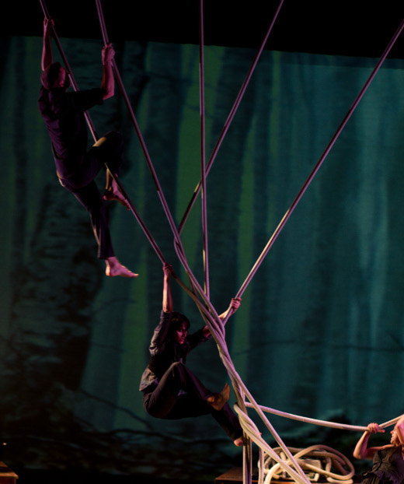

The Hanging Sphere

American choreographer, artist and director Kevin O'Connor on ensemble aerial, Axis Syllabus, contemporary circus in the USA, and the inspirational movement of gibbons.

I grew up in a commune in London, Ontario and was immersed in improvised dance training and visual arts from a young age. After high school I completed a Science degree in Natural Resource Conservation at the University of British Columbia, where I studied wild salmon populations, mountain lions, and worked on land use plans. In Vancouver I developed a rigorous ashtanga yoga and capoeira practice. After graduating I decided to pursue my artistic interests full-time.

I was keen on exploring and researching body knowledge through practice as opposed to academic work, and moved to London, England to train at Circus Space. I developed a trapeze piece there and then auditioned for the École nationale de cirque in Montreal, got in, and specialised in corde lisse and minored in clown there. After graduating I moved to New York and immersed myself in the city, working for a site-specific dance company called Sens Productions and teaching a lot of corde lisse classes.

I watched a lot of performance art, became involved in the contact improvisation world, went to shows in the downtown dance scene, and performed in the nightclubs. I produced my first installation piece with seven aerialists in a small warehouse space in Brooklyn. After that I started to receive funding from the Canada and Ontario Arts Councils and produced The Sunlight Zone, a full-length show which toured to California and Ontario.

I currently live in Oakland, California. There’s a great dance and circus community, and many circus artists here are also interested in performance art, dance, contact improvisation... I’m particularly inspired by the work of Keith Hennessy — originally from Canada and now based in the Bay Area with his company Circo Zero. His work is both political and queer.

It was in London that I first started my studies of the Axis Syllabus with the teacher and dancer Frey Faust. The objective of the Axis Syllabus is to propose a practical method for instilling safe reflexes and logical responses to the problems of moving. Essentially it’s a research platform for the study of applied biomechanics. The knowledge gained from AS allowed me to respect the structural integrity of the body while moving, and when I went to the National Circus School in Montreal, Axis Syllabus provided me with an invaluable tool for self-defence during the rigorous pedagogical process of the circus school environment. I was always questioning the value of holding extended hyper-flexible positions while on aerial apparatuses, and I became much more interested in transitions between rest points and the harnessing of gravity as I moved through the vertical sphere. Axis Syllabus also greatly influenced my interest in finding ways to link the vertical sphere to the horizontal sphere through movement. On a practical level I used to be frequently injured and now for the most part I’m injury free.

My piece Habitat, performed by six aerialists on six ropes, was inspired by watching videos of gibbons in their arboreal home swinging gracefully and efficiently in the forest canopy. Their natural locomotion evolved in relation to their environment. I’m currently doing an MFA in choreography and through that became reacquainted with the computer lab, where students spend countless hours sitting and staring into a computer screen. Habitat examines the effect of our built habitats on our movement. I was questioning how our built environments (in this age of digital technology), constructed solely for human use, dictate the movement of the body. As we become more dependant on technology do our movement patterns become smaller and smaller?

Most of the artists in Habitat had trained with me in rope for a number of years. In many ways the piece was an accumulation of the training we had done together. Each of the artists was interested in exploring movement from the horizontal to the vertical sphere, partnering on the rope, and focusing on how gravity influenced the body in space. We spent a couple years really playing with how to harness gravity. We worked with using the fall of a limb, or harnessing the energy of the fall to move somewhere else. At one point we trained at a friend’s house off of a tree, swinging off a fence from one rope to another. Then we found a studio where we could hang eight ropes in a row and just practice the idea of ‘walking’ while swinging. Research has shown many biomechanical similarities between brachiation (swinging from one hold to another in trees) and walking. We all developed powerful one-arm grips.

Habitat came together in three weeks. We watched YouTube videos of gibbons. We created patterns we played with on the ropes. I set an improvised score for the movement of the set and the way we interacted with the set as a whole. Often in creating longer, group aerial pieces it’s important that each individual artist has moments of rest and moments of being on the ropes. The arms get burnt out and so it’s important to incorporate rest movements in each individual pathway. I designed a set that we worked within, and collaborated with Homunculus Rex, a two-man digital/live glitch acoustic music experiment based in Santa Cruz.

I’m interested in aerial as a component of larger creative projects. At the National Circus School in Montreal there was so much focus on developing a five-minute solo which you make over three years so you can sell it and tour it. That structure didn’t allow me to play and be creative within the vertical realm. Working with larger casts and multiple hanging points allows me to explore the possibilities of moving in space from the vertical to the horizontal, via all the points in-between. It allows the work to not focus on the individual tricks but instead on the use of space and transitions between fixed places. I’ve been working on different solos lately but much prefer collaborating with different artists when creating work.

Often my interest starts with researching an idea. I rarely start with a story or anything literal. Right now I am examining the idea of a body as a place, the porousness of places, the body as a pack not a singularity, and the ecological body. I’m always researching and playing with technique as a daily practice. However, I always need to find a connection between the practice and the idea or theme I am researching. This connection is what makes me work and I struggle with it a lot.

Habitat was based on a lot of playing with and creating within a certain technique. However, the technique did not drive the choices made. I always tried to return to the idea. I took a set design class and had to create a set for Habitat before I had created any of the work. I never usually work this way and took it as a challenge to more or less start with a fixed set and then work within it. The heap of old junk — computers and bits of different computer labs — went from a chaotic pile to something organised. That is what I was researching: the human desire to organise chaos. This was overlaid with the ape-like movement on the ropes. There is absolutely nothing linear about it. It’s a mix between circus, an installation and a performance art piece, with most of it being improvised.

I think more and more I am interested in performance art, a term which can encompass circus and dance, visual art and installation. I think all practices are important and useful. What I am questioning is not why I use the dance or circus technique but how it relates to whatever I am exploring or researching. A big difference in terms of training is the amount of time a circus artist spends perfecting one trick or working on one number. For a movement artist the focus is often not on one trick but on the transitions between places or moments.

Many aerialists forget about their connection to the floor. Without training on the floor the most graceful person in the air can look awkward on the floor. Being hyper-mobile is often useful for poses and balances but often isn’t very useful for dynamic movement on the floor.

There is hardly any support for making contemporary circus in America. If people get funding they receive it through their reputation as performance artists or choreographers. I also work on pieces with a collaborator, Ruth Douthwright, in Canada. It is much easier to get funding for contemporary circus work in Canada. We have an ongoing project working in different watersheds there: using different scores we create a site-enhancing piece, often on lakes or along rivers, that depends on audience participation to activate the place.

I’m currently working on a new piece called dis/connect. It’s being made with three other, amazing aerialists in North America (Emily Leap, Laura Stokes and Cohdi Harrell) and performance artist Jorge de Hoyos Jr. I’m also working with three singers who improvise together and with the audience to create a soundscape. This piece explores the idea of place: not fixed entities, but porous places. Places as processes, and the body, like a building, as a kind of place.

Based in California’s Bay Area, Kevin O’Connor is a director, teacher, choreographer and performer whose previous shows Dark Matter, Habitat and The Sunlight Zone have been performed in the US and Canada. He is currently undertaking an MFA in choreography at UC Davis.

Axis Syllabus: www.axissyllabus.com

More from Kevin on the relationship between arboreal apes and human locomotion: www.axissyllabus.com/page53.php

Habitat musicians Homunculus Rex: www.homunculusrex.com

Kevin O’Connor was interviewed by John Ellingsworth January 2012.

Image of Habitat courtesy of the company.
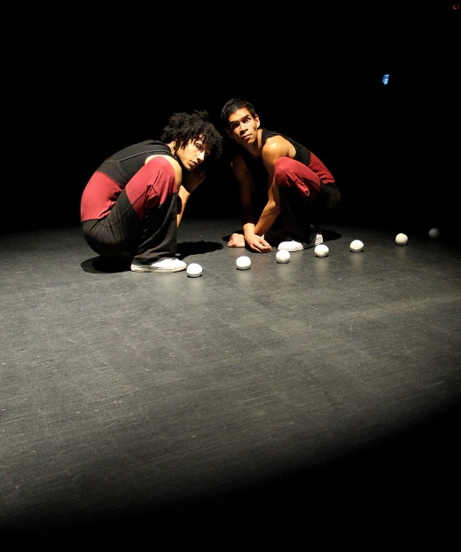

DeFracto: Circuits Fermés

Going in for the finished version of Circuits Fermés at Auch’s Festival Circa I’d seen it twice before as a twenty-minute presentation, and was stuck with this idea that it was like an opus of juggling études. In those early showings the two performers, Guillaume Martinet and Minh Tam Kaplan, had characters of a kind, these sneezing, leaping, fraternal monkey-ish creatures who were closely fascinated with the soft, white juggling balls that surrounded them — their arrangement, their texture, their taste — but the juggling itself had the high technical beauty of classical music (one scene was set in fact to a Chopin étude), the scenes/studies divided by quick blackouts and the sound of adhesive tape being ripped.

How would they adapt it for a longer format? Would they create more short études? Lengthen the pieces they’d already made? Tear it all down and start again? Having already seen three or four overlong, overstretched shows at Circa, I was cynically prepared for the possibility that the lightness and cuteness of the original creation would be overplayed, and was, therefore, delighted to see the company, after replicating the twenty-minute version almost exactly for the first half of the show, make the decision to blind and then kill one of the characters (sorry, spoiler), plunging the piece into something resembling a Cain and Abel parable played out by obsessive compulsive juggling monkeys and thoroughly destroying its prospects as a work for early years audiences.

So it’s a swerve. At a certain point Minh Tam just breaks, snapping into a catatonic state, rolling balls down the short curve of his chest, collarbone to diaphragm, over and over, staring straight ahead. Guillaume doesn’t know what to do. The crisp, warm, fast sounds — like microsecond samples of bottles and pans being played — that earlier made-up David Maillard’s soundtrack are switched out for a low, rumbling chant that circumscribes their actions with a dangerous ceremonial significance and suffuses everything with a close, expectant dread.

Obviously part of my enjoyment was predicated on the fact that I was familiar with the material and ready for something new, but I think it’s also a brave decision, and one that signals a willingness to test the borders and the capacities of their characters by throwing them out of their routine lives and into danger; in other words, to break the circuit and follow the consequences through.

In a way we’re prepared for this, with those sharp cutaways between scenes — the sound of the ripped tape — but what I think I liked about Circuits Fermés was the suddenness with which its separate elements leapt into the shape of a story. The rug is pulled out from under your feet, and you realise it has left you so little, as you frantically search through your mental notes, in terms of evidence with which to reconstruct what might have happened. Really there’s nothing — a presentiment of fragility, a flowing golden light, and this lingering sense that perhaps the clues were coded there in the juggling, faster and more intricate than you could follow.

John Ellingworth

John Ellingsworth saw Circuits Fermés at Festival Circa in Auch, France 22 October 2012. Photo: Pierre Morel

www. defracto.com
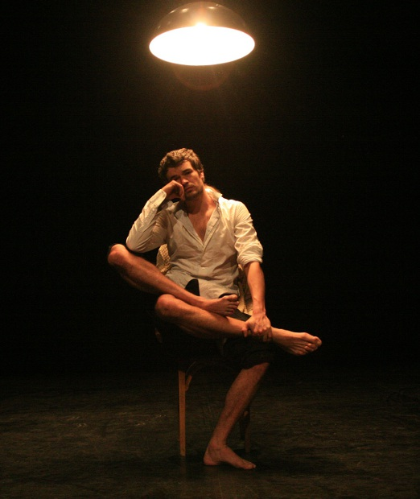

Mathurin Bolze & Hedi Thabet: Ali

When was the last time you saw a circus artist thinking? On stage, I mean, in a performance — and not acting a character who’s thinking, nor adopting a soulful posture in relation to a tress of silk about to be climbed, but actually caught for a moment in some personal and inscrutable introspection. I’m not sure whether it’s a mark of my overexposure to circus performance or a commentary on its habitually adopted forms, but I felt shocked, almost, and somehow moved to see Mathurin Bolze perched atop a supine Hedi Thabet, motionless and staring blankly out, as he retreated to scrutinise some private notion or parade of hidden thoughts.

In all of Ali there is, I think, this blankness: no agenda, no argument, and not much of a motive beyond entwining the two physicalities of Bolze, a fluid and compact acrobat and a darkly laconic performer, and Thabet, who’s bigger and heavier (with more red blood perhaps) and who, it happens, has only one leg. Thabet performs here without a prosthesis and his corporeality has obviously written the material of the piece — the two circle the stage (bare except for a plain chair and hanging light) on crutches, or share a leg to become a conjoined creature — but it’s not the subject, in the sense that Ali can’t be said to be about Thabet’s life as interpreted from this one point of fact.

The bodies of Bolze and Thabet, in the great circus tradition, are in fact just different apparatuses, imposing strict conditions for movement that set the rules of the game. In Ali, weight is the primary condition, the rule to which all invention and flight must eventually collapse back. For most of the performance the only sound is the two performers’ bodies thudding into the floor. Thabet lands a backflip with a tremendous impact; both kick out on crutches and whip back down in a heavy rhythm; with no aid Thabet crosses a darkening stage in a series of great, sporadic leaps.

If I told you the piece was abstract or poetic I’d probably give you the wrong idea. When we call something poetic we’re usually ascribing characteristics of airiness, beauty, metaphor — perhaps even using it as an insult — but for all that the lyrical register is a part of their trade, it’s the poet who takes the most delight in the heaviest, bluntest, most practical, most workmanlike forms, and it’s the poet who has the greatest skill at cutting these everyday signs free from their ordinary context. In a show like Ali the language is another, but the poet’s intelligence is there, understanding how the direct, the simple and the concrete can be the vehicles for strange emotion and deep, unseen connection. It’s OK, actually, to just crouch there and think.

Left at just 25 minutes long, Ali is memorable and intense. With no music other than a scratchy old record to play the performance out and in, it demands and repays the concentration of its audience; without sentimentality, it offers no guide to how you should feel or respond. Ideas of tenderness, dependency, trust and friendship are ghostly and dissolving, and states of aggression, cooperation and jollity are pulled away like successive masks to reveal another mask beneath. By the end it’s ‘said’ nothing; instead it’s up to you.

John Ellingsworth

John Ellingsworth saw Ali at The Place, London 28 October 2011 as part of Dance Umbrella.

www.danceumbrella.co.uk

Photo: Christophe Raynaud de Lage
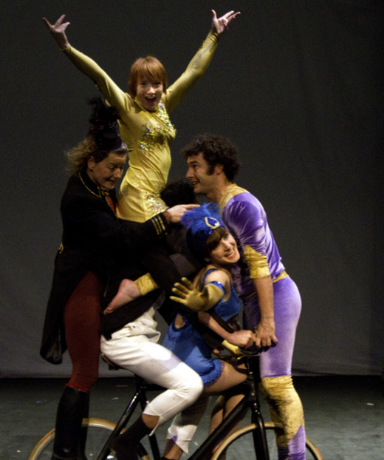

Stumble danceCircus: Box of Frogs

At a first encounter, the characters of Box of Frogs all feel like they’re about ten years-old. Kaveh Rahnama talks constantly and inconsequentially about his mania for collecting circus-themed toys and knick-knacks, shouting with delight when Amazon finally deliver his King Tusk elephant and enthusing how this proud and mighty creature is (brilliantly) equipped with a foot strop to secure its plastic rider — an innovation without precedent in the history of toy manufacture. Ringmaster Paddy Waters is either hiding away or repeatedly presenting himself with a flourish (‘a-ha!’). Lauren Hendry charts a wild course between squealing hyperactive outbursts; Silvia Pavone is the more sullen and teenaged. Juggler Chris Patfield and corde lisse artist Lyn Routledge are, in different ways, a little outside of things.

Supported by the Unlimited fund, billing itself as a ‘bipolar circus’, Box of Frogs is an uncertain and many-angled look into interpersonal conflict and close living (as, I’d guess, an analogy for intrapersonal conflict) that has an uneasy sense of fake authenticity. It chooses openness as a performance mode — the characters walk easily on and off stage to drag on props, or call out to the soundman; there’s a live band there in the corner — but at the same time those characters feel often like brittle and annoying caricatures, pushed to personality’s edge. Lyn Routledge spends most of her time somewhere on the scale between annoyed and furious — at Chris’ juggling, at Kaveh’s talking, at everyone’s childishness. As she climbs her rope she counts aloud for rage management, Kaveh babbling away on the floor, but her anger, too, feels acted, scripted, and the escalation of numbers became, for me anyway, more annoying, more abrasive, than the thing it was masking. There’s no relief, and I suppose that’s the point, and I suppose as well it would be easy and simple to make out that a few minutes of aerial can be the source of sublime calm, but I felt tight and on edge watching these sequences, as though I was being mistreated or badly handled for the fact of my attention — as though it was provocation without enlightenment.

There are, as well, a few dramaturgical choices in Box of Frogs that I couldn’t make head nor tail of. The blank back wall of the set receives massive projections that also circuit through the several TV screens lining its base, fracturing and multiplying the image into simultaneous high-def replicas that have the overcharged quality of a sparkling migraine. Juggler Chris Patfield features as video only (same goes for, very briefly, Gemma Palomar), the other characters watching him on one of the televisions (either rapt or in annoyance, depending) sometimes stepping into the video to join him. The juggling itself is focused and beautiful, shot in a bare white room, Chris in training clothes, but whichever way I turn it I can’t see where ideas of physical absence, or the private space drawn from skill and intention, fit into the rest of the piece. There’s at one point video of Kaveh in his caravan showing the viewer around some of his toy collection, still in gabbling enthusiast mode, but the volume’s toned down a bit and it’s funny without being clawing, so maybe Box of Frogs is embedding commentary about the stark gap between performance personae and the artists that construct them? But what happens on stage is a performance, and the characters, for all that they might perhaps have been drawn from the traits of the cast, are personae, so I don’t know...

If Box of Frogs is bipolar then I guess I prefer its depressive phases: Lauren Hendry’s low, gutted monologue about being just muscle and blood and ‘not enough’; a gripping single hoop solo from Silvia Pavone, performed in dim light, the hoop a silvery circuit of light. So too the opening image of the show, where Paddy Waters is pulled limb-by-limb from a heap of costumes, groaning, eeping, mumbling, to mount his trick cycle for some unsteady circuits of the stage; or the closing image of Kaveh, talking talking talking, being pulled down, gently, slowly, by the other members of the cast until he’s lying on the ground (still talking, cheek pressed flat on the floor) and they’re using him as a bench while they watch an odd final animation of tumbling symbols. It’s engaging sometimes, and unusual in its apparent commitment to needling irritation, but I left Box of Frogs feeling that I’d missed something, whether it was there or not: the point at which the ideas tied together with the characters and the circus and the design; the shape and the heart of it.

John Ellingsworth

John Ellingsworth saw Stumble danceCircus’ Box of Frogs at Jacksons Lane 4 November 2011. The show is one of the ACE Unlimited Commissions and will appear again at Jacksons Lane 3-5 April 2012 as part of the Roundhouse’s CircusFest.

www.stumbledancecircus.com
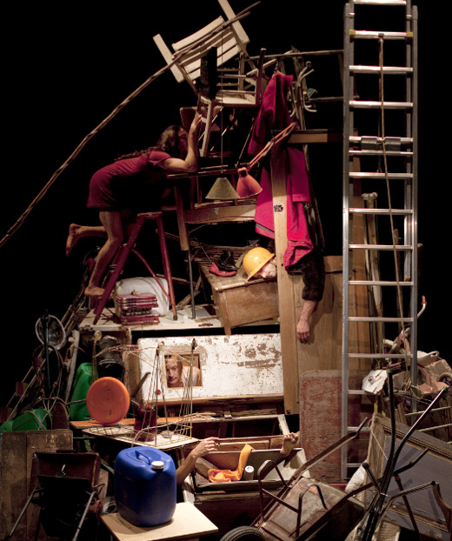

Compagnie L’Immédiat / Camille Boitel: L’Immédiat

There’s an unnamed malaise spreading through L’Immédiat: characters slip from chairs or slump to the ground like dropped coats, crawl and heave to cross the distance of a few feet, have the greatest difficulty standing or walking upright. Even the set has trouble keeping it together. Following an opening scene where the daily routines of a woman and man cross as one returns home and the other prepares to leave — the apartment around them disintegrating in a carefully orchestrated collapse as chairs, tables, pictures, coathangers and beds succumb to the dead hopelessness of it all — the walls of their tiny one-room themselves fall out and reveal a startled-looking long-haired man in a red dress. Exposed, he goes on the run, picking daintily yet clumsily through a vast stage stacked and cluttered with every kind of junk — a towering piecemeal set which, in a bravura piece of slapstick, falls apart around him: cabinets, clothes horses and ironing boards collapse, stage curtains are tangled and torn down, unsecured ladders are climbed and toppled, a stage light is grabbed and swung off, and empty plastic water containers and other debris rain from the ceiling, our man (unpursued, incidentally) haring through this elaborate environmental breakdown until he reaches and disturbs the stage-high tower of cardboard boxes that’s stood semi-occluded at the side of the set this whole time. As it tips, the audience gasps.

It’s satisfying to watch the trap sprung, but almost as pleasing are the following scenes where — after a lone cleaner has come out and failed to sweep about six skipfuls of junk under the original apartment’s small rug — the lights suddenly all come on and a knot of hairy Frenchmen in fur coats race on stage in dockers’ boots and, wielding wide brooms, heartily sweep and fling the bric-a-brac stage left and right in the equivalent of a child tidying their bedroom by piling every last object into a wardrobe or cramming it all under the bed. Here for a few minutes as well the whole of the Barbican stage is lit, across and back, revealing towers and piles of junk, and showing you — probably for the first time — a startlingly immense stage-space, in size more like a hangar, in volume feeling almost a mirror of the auditorium. In a matter of five minutes the frenetic activity of the stagehand performers clears a central area, the lights go down (imposing for me the strangest, edgiest sensation, persisting throughout the piece, that the vastness of the stage was still there, and that our peopled space was matched by its void), and with 50 minutes of show remaining, the malaise returns.

Its pervading listlessness manifests for L’Immédiat’s characters as a constant itching sense of hidden presence and withheld opportunity, or in eerie outbreaks of physical malfunction, but the show itself is most often a farce — performers running in and out of cupboards and appearing from behind the set, crossing paths and switching places. So here’s the problem: L’Immédiat is a dark, existentially barren extrapolation of the entitled conviction that what’s out of reach is always better, but the audience accept it (and are allowed to accept it) as just a piece of clever and weird Gallic comedy. The slender connection that the show seems to be making between the overbearing character of slapstick farce (THIS IS THE JOKE: HERE) and the general unbearable weight and echoing hollowness of moment-to-moment existence I think is broken by the runaway delight the audience finds in the more whimsical physicality — scenes such as those where a performer (the spidery Camille Boitel himself) is tilted at 30 degrees and held up by the fur coat team, who use a broom to brace his middle, the objects of the world around him gradually tilting into his alignment until the whole set is off-kilter; or those where a woman’s limbs are rendered magically lighter than air and she has to be saved by the others dragging her back to earth.

As the light levels dip ever lower and the visible stage becomes smaller and more closed-in (that uncanny sense of the unlit stage still pressing through), L’Immédiat interjects a long sequence where the performers crawl as though across desert toward an out-of-reach glass of water, unable once they get to it to even stand to drink it. If as it seems to be this is some commentary on the scarcity of natural resources in a world overfull with obsolete products and discarded luxuries then the pitch of it is bizarre — the audience laughing, the characters gasping and reaching. Either the ideas have no rigour or the company is too involved in their own visual aesthetic to prevent it from obscuring those ideas; I’m not sure. My own experience was that L’Immédiat was intelligent, at times pleasurable, and yet, finally, as shallow as the culture it parodied, its truths drowned out by easy entertainment.

John Ellingsworth saw Compagnie L’Immédiat / Camille Boitel’s L’Immédiat at the Barbican, London 20 January 2012 as part of the London International Mime Festival.

Image: Vincent Beaume

www.mimefest.co.uk

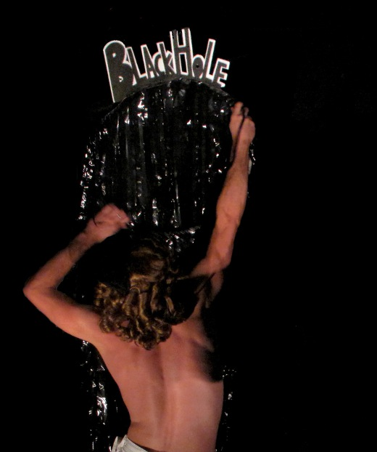

Sugar Beast Circus: {Event(Dimension):}

With blank-faced women costumed in red, white and black uniforms (an enigmatic A striped across each of their backs), looped performances, video and sound, and subject matter that touches bizarrely on the mathematical nature of reality, being welcomed into the {Event(Dimension):} space feels a little like entering a museum that hasn’t had a visitor for a thousand years and where the meaning of the exhibits has been eroded half away. The space is actually two spaces, the theatre divided by a heavy black curtain and the audience divvied up beforehand (into 1s and 0s) and led to either area/dimension by two stewards. On one side, before a wide and open stage, the audience will encounter mathematics wrapped in packets, A-girls who move forward and backward as though on rails, and a digital mountain that slumps and unravels into its constituent programming only to later reappear as an erupting, analogue volcano (lowered from the ceiling, deus ex machina volcano). On the other, in a narrow corridor of space, a story of Earth and evolution is playing out that implicates those that watch it by the fact of their observance. At half-time the audiences, without seeing each other, change sides, the soundtrack resets, and the whole mechanism plays out again...

The final event of the London International Mime Festival, and — appropriately enough — physically the most far-flung at satellite venue Jacksons Lane, Sugar Beast Circus’ {Event(Dimension):} has emerged from an R&D period that saw the company investigating the moments where the elegant mathematics of classical physics breaks down into the dizzying headfucked incoherence of quantum physics, exploring, among other things, the theory of entanglement, the behaviour of light, and the supremely unlikely business of wave-particle duality. Put simply, they picked some complex material, and even if {Event(Dimension):} isn’t looking to depict its foundational ideas literally — reformulating them instead into a particular texture of experience — I think it still has some trouble in measuring how much to explain, with small amounts of exposition coming from silent projected text (a neutral but nonetheless quite suspicious textual voice that fits with the lost museum feel), or, at one point, a 50s RP voiceover, worked into the soundtrack, giving a simple description of Newton’s ah-ha moment with the apple at the same time as aerialists on either side of the curtain master their apparatuses. I suppose a certain amount of framing is necessary, but think as well that the piece works best when it’s non-literal (notwithstanding my favourite prop: a giant observation eye, appearing after a brief intro to the double slit experiment, that projects the particle it perceives) and that any audience member who spends much time tracing back the theories expecting to find direct links and educational analogies will be led in circles.

The decision to divide the space for simultaneous performance and to double the soundtrack feels like the structural remnant of an early idea — an artefact of the original concept rather than a mechanism that arose during the devising process. It’s not disastrous, and being led through the narrow brick corridor running the back of the Jacksons Lane stage at the change of sides indulges some nosy and transgressive impulses, but by giving the audience two related performances {Event(Dimension):} is perhaps inviting a more active intellectual engagement than it’s then able to make room for: it’s put together like a puzzle, and suffused with a sort of mystery, but actually there’s no solution, the conceptual thinking behind the piece having been worked into a principally visual experience that only suggests the meanings underpinning a surface aesthetic of sensuous strangeness. Following the score of an expansive, queer, ranging, excellent soundtrack (compiled and cut together by Sugar Beast director Geneva Foster Gluck from old film soundtracks and music by Enslaved by Owls) it’s possible to connect scenes from one side to those on the other and to understand why they were paired, but, for me at least, there was no amplification or resonance between them.

In spite of all of which, I liked the piece a great deal — liked its precise, obscure arrangements, its ability to produce occasional startling uncanniness from sound and movement, and its manner of acknowledging reality only as the degraded memory of a distant past — and the problems seem to be the sort that will dissolve in the ambience of the piece given the advantage of time. It’s rare as well, in UK circus at least, to see research-based practice or aesthetic styles that are much outside the normalised devised theatre mode, and if Sugar Beast took a risk in approaching challenging material — or in premiering their work at a high-profile festival like LIMF — then I’m glad they did it with confidence, instinct, ambition and a whacked-out, singular vision of kitschy supergirls, time travel and volcanoes.

John Ellingsworth

John Ellingsworth saw Sugar Beast Circus’ {Event(Dimension):} at Jacksons Lane 28 January 2012 as part of the London International Mime Festival.

www.sugarbeastcircus.com
www.mimefest.co.uk

For reviews of previous Sugar Beast Circus shows Milkwood Rodeo and The Sugar Beast Circus Show see:

www. sideshow-circusmagazine.com/artists-companies/sugar-beast-circus
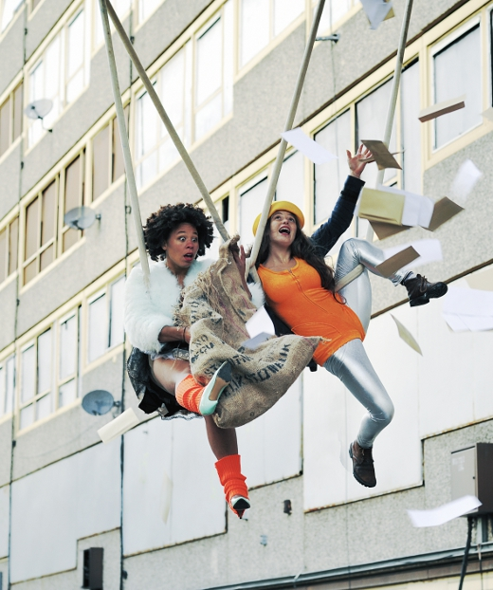

CircusFest 2012

The only large-scale, indoor UK festival dedicated to contemporary circus, the Roundhouse’s biennial CircusFest returns for its second edition in 2012, once again on a gigantic scale, once again mixing performance, film, exhibitions and talks...

There’s a lot to read elsewhere in this magazine about Cirkus Cirkör’s Undermän, one of three headline events in the Roundhouse’s own main space, and one where the only danger is that the closeness of the performance might to some degree be leeched away by the size of the venue (as, for me, was the case with Acrobat’s Propaganda at the 2010 CircusFest), but you should anyway buy a ticket — it’s a beautiful show, very finely judged, and it’s unlikely to appear anywhere else in the UK. The other two big shows are Foté Foré, a production by Guinean circus troupe Cirque Mandingue that blends circus and breakdance for a fast-paced, theatre-lite hour that, unlike Undermän, will probably be strengthened and amplified by playing the Roundhouse’s immense central venue; and Professor Vanessa’s Wondershow, a fly or die sort of a commission conceived and curated by the National Fairground Archive’s Vanessa Toulmin, designed by the Insect Circus (whose Mark Copeland won a BAFTA in his former life as a commercial model-maker) and starring Miss Behave, Marawa The Amazing, and Jon Marshall and his Sideshow Illusions that will turn the Roundhouse into village green for ‘a magical immersive carnival experience that celebrates the golden era of circus’.

Among the smaller works at the HQ venue, the most interesting are perhaps Lost Post, the new show by the Roundhouse’s Associate Artists Collectif and then..., and a piece that’s been inspired by the themes of broken communication that run through Jonathan Safran Foer’s intermittently magic realist — or at least extremely weird — Extremely Loud and Incredibly Close; The Great Spavaldos, a commission from Il Pixel Rosso (a company working with video goggles to immerse small audiences into strange narratives) that will see two people at a time enter the Roundhouse’s tiny Studio Theatre to take on the starring roles of flying trapeze brothers The Great Spavaldos (sounds promising and comes with a good Please Note: ‘This show is not suitable for people with heart conditions or fear of heights’); The Invisible Journey, a solo show from Invisible Circus co-founder Doug Francis which is essentially an entertaining 90 minutes spent listening to some of the best and most amazing anecdotes from a man with a peerless store of amazing anecdotes; and a talk from John-Paul Zaccarini, Circus on the Couch, that collects and presents the research he conducted for his PhD in circoanalysis (his own hybrid discipline mixing psychoanalysis, ethnology and phenomenology).

Off-site watch out for So & So’s new production Backgammon for Beginners, which began from the true story of performer Kaveh Rahnama’s father’s experiences in England as an Iranian immigrant, playing at Jacksons Lane; Stumble danceCircus’s Box of Frogs, also at Jacksons Lane (review on pages 38-39); and Belgian duo Compagnie Rasoterra’s Dirty Laundry, a trick-bike duet directed by Firenza Guidi, best known in these parts for her work directing the two big NoFit State tent productions Immortal and tabú.

Running througout the festival, and even beyond its confines, there are also two photographic exhibitions — one from Ben Hopper, of subjects from London and Auch, which will be at Jacksons Lane, then artsdepot; and Phil Fisk’s Everyday People, a series of often quite surreal portraits of circus performers in quotidian settings.

John Ellingsworth

The 2012 CircusFest runs 28 March - 29 April 2012 at the Roundhouse, Jacksons Lane and artsdepot.

www.roundhouse.org.uk/circusfest

Image: Collectif and then..., Lost Post (photo Phil Fisk)

Colophon

Hfff. Or, en Français: Pfff.

I’m so glad that’s over. Aren’t you? Seeing as how this issue has been published roughly three months after the first we’re perhaps sliding into a quarterly schedule — which would give us both a solid twelve weeks to recuperate and pull our shit together for Round 3...

For now, though, farewell. For the sake of full disclosure, and at the behest of contractual obligation, it only remains to indicate that while most of the articles in Sideshow are credited to named writers, in reality the bulk of the editorial work was undertaken externally by staff at the media solutions company Mumbai Future Digital Plc, without whom this magazine would not have been possible. I thank them.

John Ellingsworth
sideshow@sideshow-circusmagazine.com

© Sideshow Circus Magazine
All rights reserved

The views expressed or the opinions stated in Sideshow Magazine are not necessarily the views of the editors or publishers. Similarly, statements made or opinions expressed by the advertisers are not necessarily shared by the editors or publishers. Reasonable care has been taken to avoid error in the magazine, but no liability will be accepted for any errors which may occur. No material in this publication may be reproduced in any way
without the consent in writing of the publisher.

Sideshow Magazine accepts no liability, responsibility or blame for any dark and/or troubling thoughts that may irrupt suddenly and shockingly during the reading of this fine publication.


